**Documentation For The Hotel Reservation System**

**By**

**Dave Paclita**

**John Lian Vasquez Sarah Romero**

**From BSIT 2A3**

**Miguel Antonio Chavez**

**Our Professor**

**Project Overview**

This hotel reservation system is a website which aims to facilitate the bookings of hotel rooms. The aim of this system is to streamline the processes of booking to be easy, pleasant and intuitive. It’s made for many types of users, that are tourists going to spend their holidays, business travelers who need accommodation for working, and anyone seeking temporary lodgings.

This system enables the users to perform some functions that are essential. Firstly, they are able to view the different hotel rooms that can be booked. Also, they can select their intended check-in date (that is the day when they hope to arrive at the hotel) and check-out date (that is the day when they plan to leave the hotel). The assignees may also include the intended number of occupants per room, which assists the hotel in preparing the room appropriately. Lastly, the system displays thumbnails of several rooms and the corresponding charges which users are to expect upon booking the room.

This hotel reservation system has borrowed the interface’s appeal from that presented in Airbnb.com so as to ease the booking process. The project’s distinctive feature, which is easy access and reliance, should help accomplish the goal of this site: the needs of all types of guests. (Airbnb | Holiday Rentals, Cabins, Beach Houses & More, n.d.).

**Prototype Description**

The website, or ‘user interface’, is constructed in a manner that is clear and adheres to the rule of minimalism. This means that users do not lose their way when searching for something that they would like to access. A few of the most concerning aspects of the design will now be discussed:

Image Grid: While the mouse pointer is moved over the Image Grid, interface changes take effect quite rapidly as the primary purpose of the interface is to ease the panning across the pictures. The main page is filled with the images of the different hotel rooms which are arranged in the grid format. The images displayed in the grid are arranged in a way that makes it easy for the users to see what each room looks like. Once the user points his/her mouse on an image, the image increases in size slightly, followed by a description of the image that contains relevant details such as its cost which in this case, is the price of the room. It fosters interest of the user to the design who now wishes to see what the alternatives are.

Booking Form: Another crucial component of the system is the booking form. The booking form constitutes of details such as the check in and the check out dates and the amount of guests. The process of filling in this form shouldn’t be very complicated, the items should be clearly labelled. Information entered by the user is verified as it is being entered. This feature reduces the chances of making an error when the user is providing the necessary information.

Owner and Description Sections: For each room, there is a section that gives users more details about the room, the hotel, and the person who owns or manages the hotel. This includes details about the amenities (like Wi-Fi, breakfast, or pool access), the hotel’s rules, and anything special about the room. By providing these details, users can make better choices about where they want to stay.

Interactive Hover Effects: Interactive “hover effects” are used on buttons and other parts of the page. When users move their mouse over these areas, the design changes a little (like the color or size), which shows the user that they can click on it. This feature helps users know what parts of the page they can interact with, making it fun and simple to use the website.

**System Requirement Specifications**

To use the hotel reservation system, users need to have certain software and devices. Here’s a list of what’s needed:

Operating System Compatibility: The system works with almost any modern operating system, including Windows, macOS, and Linux. This means it can be used on most computers and laptops.

Hardware Requirements: For the best experience, users should use a device with at least 4GB of RAM. This amount of memory helps the system run smoothly without freezing or slowing down. Users will also need a modern web browser, like Chrome, Firefox, Safari, or another up-to-date browser, to use the system effectively.

Functional Requirements: The system includes important features that make it useful, including:

Browsing Hotel Rooms: Users can look at different rooms with descriptions and prices.

Interactive Booking Form: Users can fill in the booking details quickly and easily.

Responsive Layout: The system adjusts its layout to fit different screen sizes, so it works well on phones, tablets, and computers.

Hover Effects: These effects help users know which parts they can click on, making navigation easy and enjoyable.

**ER Diagram & Business Rules**

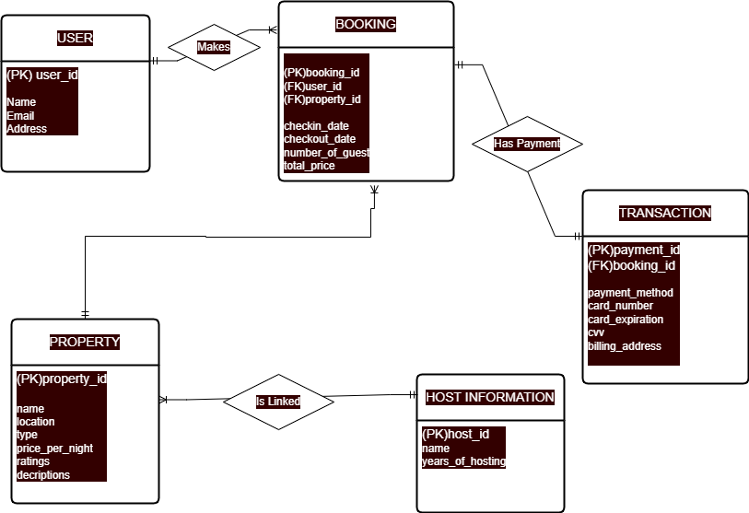

**Data Restrictions**

Mandatoy Required For User: Name, Email, Password

Mandatoy Required For Property: Title Description, Location, Price Per Night

Mandatoy Required For Booking: Check in date, Check out date, Number of guest

**User Rules**

User need to have unique user_id

Valid email

Can leave reviews per stay  
 A user can make many bookings, but each booking is only made by one user.

**Booking Rules**

Booking need to have unique booking id

Check in and Check out date required minimum of 1 night stay

The total price will depend on the number of guests and a night of stay

One or many bookings can only be manage by user

A property can have many bookings, but each booking links to only one property

**Payment/Transaction Rules**

Unique payment_id

Many choice of cards

Card is valid not expired

Each booking has one payment, and each payment belongs to only one booking.

**Property Rules**

Unique every propery_id

Have filled description with price host information

**Host Rules**

Name and Years of hosting must be shown

A host can manage many properties, but each property is managed by only one host.

**Justification/Conclusion**

In designing a hotel reservation system, the Human-Computer Interaction (HCI) principles were adopted with the aim of providing a user-friendly and enjoyable experience to users. In this regard, let us take a look at some of the design selections and their reasons:

Hover Effects: The hover effects provide a visual cue to the users and indicate the areas which are active and may be clicked. Users perceive these effects as a guide as it enables them to understand what actions are possible as they navigate through the site.

Simple Layout and Fonts: The fonts are legible while the margins are large, in order to avoid cluttered arrangement. As a result, users can easily locate the desired details without becoming overwhelmed.

Accessible Color Scheme: The colors have been selected in such a way that they have a good contrast ratio which enhances visibility. This enhances a high level of user friendliness of the system which also fosters the visually impaired users as well, which is rather a great consideration for usability.

Responsive Design: The system has been developed in such a way that the usability is consistent across various devices including mobile phones and desktop devices. This means users can access the system in whatever way is most convenient for them, which makes it easier for more people to use.

To conclude, the prototype for the hotel reservation system is user-centric and aesthetically attractive while being fully made with the good functionality that facilitates easy booking.

**REFERENCES**

Airbnb | Holiday rentals, cabins, beach houses & more. (n.d.). Airbnb. https://www.airbnb.com/